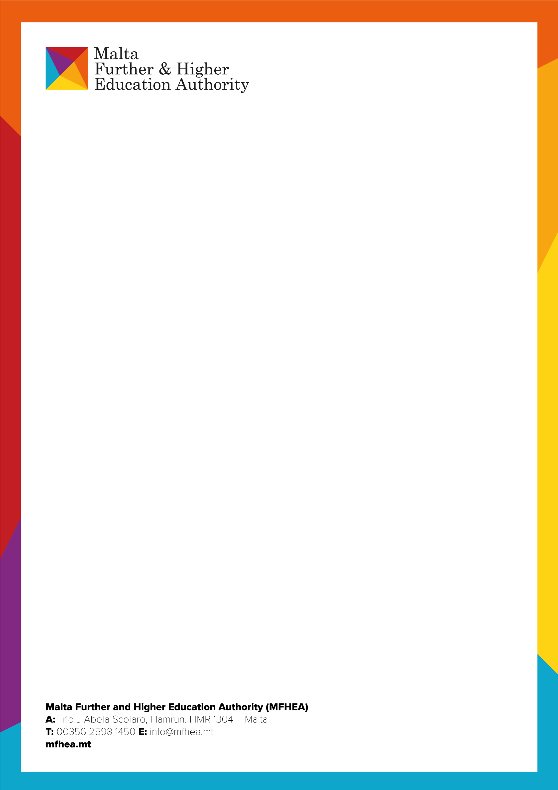
Report of the Evaluation Panel convened to consider an application from Pegaso International for a licence to operate as a university in Malta
Foreword
Rationale
The Malta Further and Higher Education Authority (MFHEA) received an application from Pegaso International Limited to operate as a university in September 2021. Pegaso International was already licensed to operate as an HEI (Licence No: 2016-001). This institution is now legally known as MED.E.A. - Digital Institution for the Mediterranean, Europe and Africa, however as the original application was submitted under the name Pegaso International, that name is used throughout this report.
The MFHEA appointed a panel of experts to address this request in terms of the legal framework regulating Further and Higher Education institutions in Malta. Its framework for action is explained below, followed by the panel’s recommendations. The remainder of the report summarises the evidence base for the panel’s decisions.

The panel met five times. Members agreed by email between November 2021 and January 2022 how they would review the application and they commenced reading the supporting documentation. However at their first meeting it became clear from the EQA audit report that Pegaso International had serious shortcomings to address. Moreover panel members had already begun their scrutiny of the documentation and found for themselves some gaps in the evidence for meeting standards. The panel decided it could not continue to consider the application for a university licence until all outstanding non-compliance issues identified by the MFHEA had been rectified. The panel met on three further occasions to consider Pegaso International’s situation. At the fourth meeting, in January 2024, the panel decided that, while Pegaso International had clearly made progress in tackling non-compliance issues, the most recent MFHEA follow-up site visit (November 2023) showed Pegaso International was still not fully meeting all expected standards for their HEI licence, and thus could not be meeting the standards required of a university either. At this point the panel felt that the time had come for it to recommend the MFHEA to refuse the licence application. However the MFHEA responded that Pegaso International was appealing the most recent site-visit report, as it had the right to do, and requested the licence application panel to suspend any decision until the challenge had been considered.

The licence application panel duly complied with this request. It re-convened in September 2024 to consider the outcomes of the appeal. It also received and considered a progress report from Pegaso International.
The panel’s framework for action is explained below, followed by its recommendations. The remainder of the report summarises the evidence base for the panel’s decisions.

The evidence base How the licence application panel reached its judgements
The licence application panel was appointed in November 2021. Its initial meeting date was postponed twice but members agreed by email between November 2021 and January 2022 how they would work together to review the application, and they commenced reading the supporting documentation. Subsequently they met online five times: March 2022, April 2022, November 2022, January 2024 and September 2024.
At the first panel meeting, in March 2022, the Quality Assurance lead at MFHEA outlined serious concerns following an EQA audit of Pegaso International, carried out between 14th and 18th February 2022, whence a significant number of non-compliance issues with its institutional licence had emerged. Panel members had already shared concerns with each other by email, many of which overlapped the findings of the EQA audit. They decided that they could not proceed immediately to consider the licence application for university status. Members agreed to await the imminently forthcoming official EQA report before deciding what to do next.

In April 2022 the panel met again following the production of the EQA report for the February 2022 audit. Having read the report panel members still did not feel they could proceed immediately. They required further evidence that mandatory and key recommendations of the EQA panel had been actioned. They also requested further direction from the MFHEA about the next steps, following publication of the report and the response of the applicant to its findings.
In November 2022 the panel convened for the third time. On this occasion members formally summarised the issues which precluded proceeding further with the application. The panel had concerns about (but not confined to) misleading advertising, lack of ethical processes, including use of reputable plagiarism software and with regard to student research projects, absence of clarity about how Learning Outcomes were assessed, shortfall in academic resources (including access to literature, especially peer reviewed journals), breadth and depth of current research activity of staff, and the absence of a Quality Assurance officer with a defined and proactive role. At this point only one of the seven overarching questions outlined in Article 47 potentially had a positive answer. The panel considered advising the MFHEA at that point that the application for the new licence should be refused. However, after careful thought and advice from MFHEA personnel, the panel decided instead to suspend its consideration of the University application pending the follow-up site visits to Pegaso International which would indicate how much progress had been made towards full compliance its licensing conditions. These visits took place in November 2023.

The fourth meeting of the panel was held in January 2024. For this it had access to the most recent EQA follow-up site visit report. This report made it clear that Pegaso International had made progress, particularly with regard to written claims about creating guidelines, protocols and processes for guiding teaching and assessment, improving staff CPD and increasing research involvement. The panel considered that all these things had potential for producing improvement and they indicated a shift towards full compliance. However the follow-up site visit report did not include sufficient evidence for the realization and impact of these changes on the educational offering to show things were working well. The panel acknowledged that there has not been time for many of them to take full effect, but the panel is obliged to look at outcomes, not merely good intentions described in documentation. Moreover in some areas it was going to take months, or even years, before the impact on outcomes was fully and reliably evident. Furthermore, the report findings and responses did not fill in all the gaps in the original application. The panel therefore decided at this point that, while Pegaso International had clearly made progress in tackling non-compliance issues, the most recent MFHEA follow-up site visit in November 2023 showed it was still not fully meeting all expected standards for their HEI licence, and thus could not be meeting the standards required of a university either. The panel had serious concerns that Pegaso International was not yet able to operate Quality Assurance processes at the level required of a university. The panel felt that the time had come for it to recommend the MFHEA to refuse the licence application.

At this point the MFHEA responded that Pegaso International was appealing the most recent audit report and requested the licence review panel to suspend its decision once again until the challenges made had been considered. The licence application panel duly complied with this request.

The fifth and final meeting of the panel was held in September 2024. It reviewed its earlier judgements, and also considered the outcomes of Pegaso International’s recent appeal. Additionally it received and considered a progress report submitted to MFHEA from Pegaso International which covered the time from March 2024 until 19th August 2024.

The panel noted that Pegaso International’s appeal had challenged nine judgements of the November 2023 EQA audit, of which only one was ultimately revised. The audit appeal panel had helpfully explained its decisions in considerable detail, explanations which seemed to suggest a substantial mis-match between MFHEA’s requirements and Pegaso International’s understanding of them. Moreover the comments of the audit appeal panel chimed closely with the licence application panel’s concerns that Pegaso International frequently presents actions it has taken without supporting evidence of their impact.

Furthermore, the documentation submitted for the original application, which itself showed many shortfalls, is now well out of date. Substantial work would be needed to update this to reflect recent improvements in Pegaso International’s Quality Assurance, and more time must inevitably pass before data can be collected as evidence that improvements made have had a beneficial impact on teaching, learning, research, and dissemination of knowledge, i.e. the core business of a university. The original application will inevitably be further out-of-date before all this can happen, and when it can, further change in the next two or three years will also have to be reflected. Current concerns about Artificial Intelligence, for example, may have to be addressed in future documentation, alongside other issues which the licence application panel itself cannot yet foresee.

A licence for university status requires the accredited institution to demonstrate positive impact on teaching, learning, research, dissemination of knowledge and all other aspects of its work, arising from effective Quality Assurance policies and procedures which it is capable of monitoring independently. The licence application panel did not find this to be the case currently at Pegaso International. However, recent progress made suggests that Pegaso International may in time be able to meet the required standards. The panel cannot predict the future, but felt sufficiently positive to recommend that Pegaso International might be able to re- apply in due course for the licence which it seeks.

How the panel presents its judgements
The panel used Article 47 requirements to frame its judgements, evaluating the documentation to which it had access to answer the overarching questions in Article 47 Annex 1. Based on these its recommendations to the MFHEA are listed below. Panel findings follow on thereafter under the Article 47 Annex 1 question headings.

Recommendations

Recommendation 1: The panel recommends that the MFHEA should refuse to grant a licence to Pegaso International Limited to operate as a university in Malta. This in no way negates Pegaso International’s current licence to operate as an HEI in Malta: it may continue to provide courses and award qualifications under that licence.
Recommendation 2: Pegaso International Limited should postpone making any further application for a licence to operate as a university until it has made further progress on current initiatives intended to improve its teaching, learning and research capabilities, has accumulated evidence of their impact, and has had a further successful Quality Assurance audit under its present licence.

Furthermore, the documentation submitted for the original application, which itself showed many shortfalls, is now well out of date. Substantial work would be needed to update this to reflect recent improvements in Pegaso International’s Quality Assurance, and more time must inevitably pass before data can be collected as evidence that improvements made have had a beneficial impact on teaching, learning, research, and dissemination of knowledge, i.e. the core business of a university. The original application will inevitably be further out-of-date before all this can happen, and when it can, further change in the next two or three years will also have to be reflected. Current concerns about Artificial Intelligence, for example, may have to be addressed in future documentation, alongside other issues which the licence application panel itself cannot yet foresee.

A licence for university status requires the accredited institution to demonstrate positive impact on teaching, learning, research, dissemination of knowledge and all other aspects of its work, arising from effective Quality Assurance policies and procedures which it is capable of monitoring independently. The licence application panel did not fin this to be the case currently at Pegaso International. However, recent progress made suggests that Pegaso International may in time be able to meet the required standards. The panel cannot predict the future, but felt sufficiently positive to recommend that Pegaso International might be able to re- apply in due course for the licence which it seeks.

How the panel presents its judgements
The panel used Article 47 requirements to frame its judgements, evaluating the documentation to which it had access to answer the overarching questions in Article 47 Annex 1. Based on these its recommendations to the MFHEA are listed below. Panel findings follow on thereafter under the Article 47 Annex 1 question headings.

Recommendations

Recommendation 1: The panel recommends that the MFHEA should refuse to grant a licence to Pegaso International Limited to operate as a university in Malta. This in no way negates Pegaso International’s current licence to operate as an HEI in Malta: it may continue to provide courses and award qualifications under that licence.
Recommendation 2: Pegaso International Limited should postpone making any further application for a licence to operate as a university until it has made further progress on current initiatives intended to improve its teaching, learning and research capabilities, has accumulated evidence of their impact, and has had a further successful Quality Assurance audit under its present licence.

The evidence base
Article 47/1: Are HE, teaching, research and dissemination of knowledge the primary activities of the applicant?
  - This requirement is largely met. However the various areas of provision are not equally strong.
  - Higher Education is indeed the primary activity of the applicant. It is already operating as an HEI under licence in Malta and is fully engaged in teaching. Nevertheless, although the nature of distance learning obviously constrains interaction between teachers and learners, some of the students who contributed the recent EQA follow-up site visit had found interaction noticeably limited, particularly in the PhD programmes.

  - In addition, evidence regarding the research activity of academic staff employed by Pegaso International and its influence on teaching is scanty. The panel reviewing the application therefore has concerns about dissemination of knowledge, because the research element is not strong.

Article 47/2: Does the applicant have academic staff, an academic library, and stable research training or stable research and development activities of a high standard?
  - This requirement does not appear to be fully met because of the limited research activity already mentioned in 1.3 above.
  - According to the application documentation the applicant appears to have sufficient staff. The recent EQA follow-up site visit report indicates improvement in access to academic resources including an online library. Development activities include an in-house conference and encouragement to staff to participate in research. However much of this activity is recent and the panel is unable to evaluate the extent to which it may lead to the high standards necessary for a fully positive answer to this question. More evidence of positive outcomes is needed.

Article 47/3: Does the applicant have representative bodies of staff and students? Do these bodies meet regulatory requirements?

  - This requirement does not appear to be fully met.
  - The recent EQA follow-up site visit confirmed that Pegaso International does have representative bodies of staff and students, but its report also stated they are not all used well. It is therefore unclear whether the activities of these bodies meet regulatory requirements for a licence to operate as a university.

Article 47/4: Are the applicant’s organisation and infrastructure appropriate for providing
higher education and undertaking research?

  - The panel is unable to make a judgement on this issue. The evidence it has is broadly positive but insufficient for certainty.

  - The recent EQA follow-up report is positive about Pegaso International’s adoption of a continuous improvement approach, at least in principle. As one example, progress has been made in specifying requirements for English Language fluency and supplying support to students for whom learning and writing in English for academic purposes presents challenges.

  - The gap in information is therefore not about strategies but their impact on its provision. For instance, how effectively are teaching staff responding to the guidelines and opportunities for professional development which they are now receiving? How many of them are now undertaking research, attending conferences, and engaging with the wider research community? And how, and to what extent, is this influencing and improving teaching and outcomes for students?

  - The applications panel had concerns that there may not yet be full understanding within Pegaso International of how Quality Assurance policies and procedures must lead to visible outcomes. The findings of the Appeals Board, which rejected all but one of Pegaso International’s challenges to its most recent EQA audit, suggests this might be the case.

  - Comments under 3.2 also apply here.

Article 47/5: What independent competence in setting up HE programmes does the applicant already have? What programmes does the applicant already provide? Who accredits them? Does the applicant already have an independent right to award degrees for such programmes?
  - This requirement is not fully met.

  - The recent EQA follow-up report indicates lot of work in progress, some of which infills gaps in the original paperwork supplied to this panel. However there is insufficient about outcomes. As an example, the recent site visit report indicates frequent mention in documents of monitoring but without any precision about how monitoring is defined or carried out.
  - A particular matter of concern to the application panel originally was the absence of a Quality Assurance officer and clarity about their role. This post now exists, and has been filled, but the appointment is recent and the individual appointed has not had time to make an impact. This is a key role in sustaining the quality assurance required for independent award of qualifications by a university. The licence application panel found many references in the latest progress report from Pegaso International to work which the Quality Assurance officer plans to undertake. One example indicates intention to evaluate their own engagement with accrediting bodies, industry partners, and alumni, analysing and incorporate their feedback to enhance the institution's quality, but there was no evidence that this work is currently in progress or, crucially, of any impact so far.

Article 47/6: To which international HE and/or research networks is the applicant already affiliated?
  - The panel is unable to make a judgement on this issue. The evidence it has is broadly positive but insufficient for certainty.
  - There is evidence of some affiliation to appropriate networks. Pegaso International is a member of the Multiversity network of universities aiming to provide “international students worldwide with a flexible, inclusive and accessible education” (https://pegasointernational.eu/about-us/mission-and-vision, 27-01-24). Such a network has clear potential benefits for Pegaso International. Moreover the recent EQA follow-up visit report
supplies evidence that the applicant is seeking wider affiliation to appropriate international HE
networks, and is using Erasmus Plus for staff development, though Pegaso International could provide more of the latter in-house. There are some indications of research conference involvement. Requirements may be met but evidence of impact of all current activity in this area is missing.

  - Comments under 2.2 and 4.3 above also apply here.



Article 47/7: How does the applicant participate in national and international teaching and/or research?
  - The panel is unable to make a judgement on this issue. The available evidence is insufficient for the panel to be convinced that positive change has occurred.
  - The original application documents do not supply sufficient evidence. The recent EQA follow-up site visit found that Pegaso International is seeking to expand activity in this area (see 6.2 above) but the extent of systematic and active staff and student participation is unclear.

Thanks
Panel members appreciate the professionalism and dedication of MFHEA staff who have supported their work, including the EQA audit team and appeal review team. who have provided clear, well-evidenced judgements in their reports.

Panel Signatures
Dr Janet Harvey
Chair

Dr Doreen Said Pace



Prof Emerita Pat Sikes


